User-Centered Design and Planning for Amanda Mobile App

Understanding the Users and Requirements
This section focuses on who the users are, what they want to achieve, and what the app must do.

Personas:


Sara
- Demographics: 28 years old, professional, lives in a city
- Background: Recently experiencing relationship stress, tech-savvy, comfortable with mobile apps
- User Scenario: Sara wants to talk to Amanda after work to reflect on her relationship issues privately
- Goals: Receive empathetic, reflective advice; explore relationship problems safely
- Challenges: Feels hesitant sharing personal information; prefers text-based interaction for privacy

Alex

- Demographics: 20 years old, student, lives in shared housing
- Background: Busy schedule, sometimes stressed, prefers quick access to support
- User Scenario: Alex wants to use voice chat with Amanda on the go when feeling anxious
- Goals: Access quick, supportive guidance; feel emotionally safe
- Challenges: Needs simple, intuitive interface; may be distracted while using the app

User stories:

As a user, I want to send text messages to Amanda so that I can receive relationship advice anytime.
As a user, I want to speak to Amanda using my voice so that I can interact hands-free.
As a user, I want to see Amanda’s responses in a chat format so that I can follow the conversation easily.
As a user, I want to receive helpline information if I show signs of distress so that I can access help in a crisis.
As a user, I want to see a disclaimer before using Amanda so that I understand it is not a replacement for therapy.
As a user, I want to log in optionally so that I can save preferences and previous session data.
As a user, I want to toggle between text and voice input so that I can choose my preferred interaction mode.

Define Functional and Non-Functional Requirements

Functional Requirements (what the app must do):
- Allow users to send text messages to Amanda
- Allow users to send voice messages to Amanda
- Display AI responses in the chat interface
- Show disclaimers before starting the session
- Optionally allow users to log in and save session preferences
- Provide helpline information if crisis language is detected
Non-Functional Requirements (how the app behaves / quality constraints):
- App must be easy to use, with intuitive navigation
- App must ensure privacy and optional anonymity
- App must respond to user input within a reasonable time
- App must be accessible (readable fonts, clear layout, voice support)
- App must provide an emotionally safe and supportive user experience

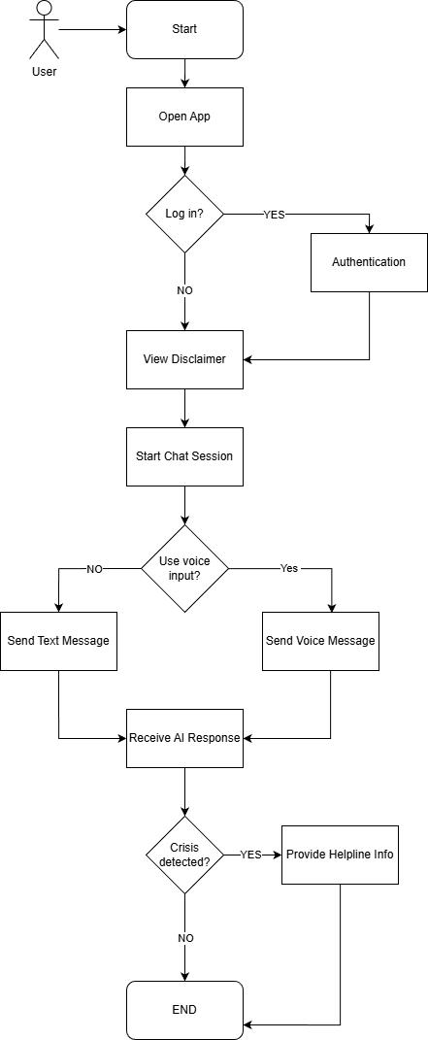
User Flowchart

Represent Functional Interactions in Diagrams
Use Case Diagram → Visual map of actors and actions
Matches the user stories

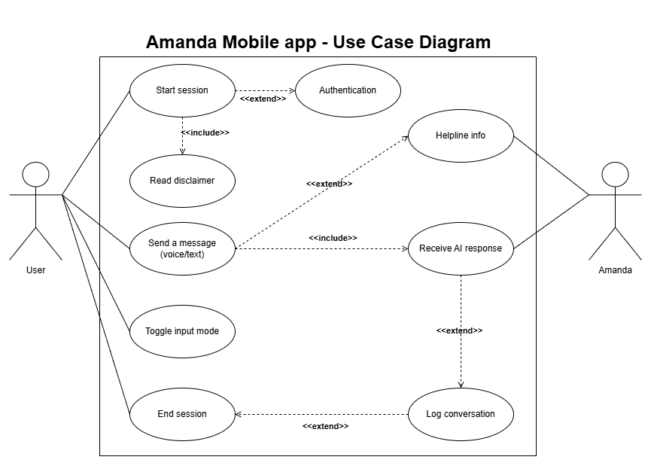

I use include relationships for mandatory sub-actions, like the disclaimer being included in every session.
Extend relationships show optional or conditional actions, such as login, helpline provision, or conversation logging.

Plan ethical and safety considerations
Plan how the app handles sensitive conversation
- Crisis detection, disclaimers, data privacy, anonymization

1. Crisis Detection
- The app will monitor messages for language indicating distress, self-harm, or crisis.
- If detected, Amanda will provide pre-approved helpline information immediately.
- Crisis detection ensures users are directed to professional help if needed.
- Keywords or sentiment analysis trigger a response:
“It sounds like you’re feeling very distressed. Here’s a helpline you can contact immediately…”
2. Disclaimers
- Before using the app, users will see a clear disclaimer stating:
  - Amanda is not a substitute for professional therapy
  - Responses are AI-generated and should not replace medical or psychological advice
- Users must acknowledge the disclaimer to continue.
3. Data Privacy
- All user input and session data will be encrypted in transit.
- Only essential data will be stored temporarily (e.g., current session) unless the user logs in.
- Users’ data will never be shared with third parties.

4. Anonymization
- Users can choose to interact anonymously without creating an account.
- Even logged-in users’ identifiers will be separated from sensitive conversation data.

5 Additional safety considerations
- The UI/UX will be designed to reduce stress, with calm colors, readable fonts, and supportive language.
- Accessibility features (voice input/output, high contrast, text sizing) will ensure all users can safely interact.

Plan system interaction
Mobile app integration overview - how the app connect to the ai / backend

Visual design
Wireframes - design each screen in Figma

